

A SLAM BASED AUGMENTED REALITY DESIGN

Submitted in Partial fulfillment of Requirement for the award of the Degree of

**MASTER OF TECHNOLOGY**

in

VLSI and Embedded System

Name of the Student: Nehru H

USN: 1MS20LVS08

Under Guidance of

Dr. Reshma Verma

Assistant Professor, Department of E & C

**Department of Electronics and Communication**

**RAMAIAH INSTITUTE OF TECHNOLOGY**

(Autonomous Institute, Affiliated to VTU)

Accredited by National Board of Accreditation & NAAC with ‘A+’ Grade

MSR Nagar, MSRIT Post, Bangalore-560054

[www.msrit.edu](http://www.msrit.edu)

2022

**CERTIFICATE**

This is to certify that the dissertation work entitled **“A SLAM Based Augmented Reality Design”** is carried out by **Nehru H**, with **USN: 1MS20LVS08**, a bonafide student of Ramaiah Institute of Technology, Bangalore, in partial fulfilment for the award of Master of Technology in **VLSI and Embedded System** of the Visvesvaraya Technological University, Belgaum,during the year 2022. It is certified that all corrections / suggestions indicated for Internal Assessment have been incorporated in the thesis deposited in the departmental library. The thesis has been approved as it satisfies the academic requirements in respect to dissertation work prescribed for the said degree.

**Guide HOD Principal**

**Dr. Reshma Verma Dr. Maya V Karki** **Dr. N V R Naidu**

Assistant Professor Professor and HOD, Principal,

Department of E & C Department of E & C RIT, Bangalore

RIT, Bangalore RIT, Bangalore

**Name & Signature of Examiners with Date: -**

**1)**

**2)**

**DECLARATION**

I, **Nehru H**, a student of Master of Technology in VLSI Design and Embedded Systems, Ramaiah Institute of Technology, Bangalore hereby declare that the project entitled “**A SLAM Based Augmented Reality Design**” has been carried out independently at Ramaiah Institute of Technology, Bangalore under the guidance of **Dr. Reshma Verma, Assistant Professor,** Department of Electronics and Communication Engineering, RIT, Bangalore.

I hereby declare that work submitted in this thesis is my own, except where acknowledged in the text and has not been previously submitted for the award of the degree of Visvesvaraya Technological University, Belgaum or any other institute or University.

**Place: Bangalore Name: Nehru H**

**Date: USN: 1MS20LVS08 1MS20LVS08**

**ACKNOWLEDGEMENT**

The immense satisfaction that accompanies the successful completion of the project would be incomplete without the mention of the people who made it possible. I consider it my honour to express my deepest gratitude and respect to the following people who always guided and inspired me during the course of the Project.

I am deeply indebted to **Dr. N. V. R. Naidu**, Principal, RIT, Bangalore for providing me with a rejuvenating master course under a very creative learning environment.

I am much obliged to **Dr. Maya V Karki**, Professor & HOD, Department of Electronics and Communication Engineering, RIT, Bangalore for her constant support and motivation.

I sincerely thank my guide **Dr. Reshma Verma, Assistant Professor,** Department of Electronics and Communication Engineering, RIT, Bangalore and express my humble gratitude for her valuable guidance, inspiration, encouragement and immense help which made this project work a success.

I sincerely thank **Dr. Lakshmi Shrinivasan** and **Dr. Roshan Zameer Ahmed** for reviewing my project work and providing valuable suggestions. I also thank all the faculty members of Department of E&C, RIT for their kind support to carry out this project successfully.

Last but not the least I would like to express my heartfelt gratitude to my parents, relatives and friends for their constant support, motivation and encouragement.

**ABSTRACT**

Most widely Simultaneous Localisation and mapping operations are predicated on the notion of static Consequently, the camera's localization and the scene's mapping may not be accurate enough to capture moving objects in the scene. This project proposes an experimental solution to map an environment efficiently with a sophisticated approach involving an algorithm which is widely used in the field of Augmented Reality as well Virtual Reality applications. In this project we have proposed a technique for the simultaneous mapping of traversing objects by identifying the location of the moving camera and objects in the virtual scene, with the primary focus of making use of geometric segmentation to the SLAM algorithm. Taking use of such an approach has given us the ability to create a sustainable environment mapping with the use of the proposed SLAM, employing simply Our SLAM model to estimate the region’s graphical structure. In general it is arduous to establish the best relative rotation or translation in a single step in the absence of correct correspondences,  to tackle this challenge we have used the difference between two clouds of points which is minimised using an approach known as Iterative Closest Point. The aforementioned model is used to make a simulation output of mapped areas and how they are in comparison to existing SLAM based approaches used by developers currently**.** For displaying the sustainable effectiveness we demonstrate a traversing region that would be simulated in a customised environment as well as making use of datasets to analyse the various metrics.

**ACRONYMS**

AR Augmented Reality

VR Virtual Reality

SLAM Simultaneous Localization and Mapping

ML Machine Learning

AI Artificial Intelligence

DKE Dynamic Keypoint Exclusion

DS-SLAM Dynamic Semantic SLAM

ROS Robot Operating System

RVIZ ROS Visualisation

HSV Hue, Saturation and Value Color space

HSL Hue, Saturation and Lightness Color space

GPU Graphics Processing Unit

ORB-SLAM Odometry based monocular SLAM

CLAHE Contrast Limited Adaptive Histogram Equalization

HE Histogram Equalization

MRPT Mobile Robot Programming Toolkit

RGB-D Red, Green and Blue with Depth

RTAB Real Time Appearance Based

COP-SLAM Close-form Online Pose Estimation based SLAM

**Contents**

**CHAPTER 1 INTRODUCTION Page Nos.**

* 1. Introduction 1
  2. Problem definition 1
  3. Motivation of work 2
  4. Objectives 2
  5. Scope 2

1.6 Organization of the dissertation 3

**CHAPTER 2 LITERATURE SURVEY**

2.1 Review of COP-SLAM Model 4

2.2 Review of SLAM++ Model 7

2.3 Review of a Robust and Efficient RGB-D SLAM in Dynamic Environment 10

**CHAPTER 3 METHODOLOGY**

3.1 Block Diagram 14

3.1.1 Geometric Segmentation 15

3.1.2 Iterative Closest Point Algorithm 18

3.1.3 SLAM Approach 20

3.2 Hardware Requirements 22

3.3 Software Requirements 22

3.4 Implementation 23

**CHAPTER 4 RESULTS & DISCUSSION**

4.1 MRPT based Approach 24

4.2 RTAB Mapping based Approach 25

**CHAPTER 5 CONCLUSION & FUTURE WORK**  32

**REFERENCES PLAGIARISM REPORT**

**APPENDIX A**

**List of Figures**

|  |  |  |  |  |  |  |  |  |  |  |  |  |  |  |  |  |  |  |  |  |  |  |  |  |  |  |  |  |  |  |  |  |  |  |  |  |  |  |  |  |  |  |  |  |  |  |  |  |  |  |  |  |  |  |  |  |  |  |  |  |  |  |  |  |  |  |  |  |  |  |  |  |  |  |  |  |  |  |  |  |  |  |  |
| --- | --- | --- | --- | --- | --- | --- | --- | --- | --- | --- | --- | --- | --- | --- | --- | --- | --- | --- | --- | --- | --- | --- | --- | --- | --- | --- | --- | --- | --- | --- | --- | --- | --- | --- | --- | --- | --- | --- | --- | --- | --- | --- | --- | --- | --- | --- | --- | --- | --- | --- | --- | --- | --- | --- | --- | --- | --- | --- | --- | --- | --- | --- | --- | --- | --- | --- | --- | --- | --- | --- | --- | --- | --- | --- | --- | --- | --- | --- | --- | --- | --- | --- | --- |
| |  |  |  | | --- | --- | --- | | **Figure No.** | **Name** | **Page No.** | | 2.1 | Graphical SLAM, Pose-graph based SLAM, Sparsely posed SLAM, and Pose-chained SLAM. | 4 | | 2.2 | Demonstration of Closed-Form path | 5 | | 2.3 | Outputs from monocular dataset | 6 | | 2.4 | Overview of SLAM++ pipeline | 7 | | 2.5 | Demonstration of moved object detection | 9 | | 2.6 | The framework of the proposed system based on ORB-SLAM2 | 10 | | 2.7 | (a) A RGB image, (b) the outcome of region partition, and (c) regions that have been classified as dynamic due to occlusion from individuals walking by. | 12 | | 3.1 | Block diagram representation of the proposed SLAM based algorithm to be used in the project. | 14 | | 3.2 | Raw image after HE processing and Histogram representation of Raw image. | 15 | | 3.3 | The four images from left represent a low contrast, contrast matching, Histogram Equalisation and Adaptive equalisation techniques. | 16 | | 3.4 | Pictures represents the raw image for which the CLAHE and HE processing is done. | 17 | | 3.5 | A-depicts RAW image with histogram, B-depicts HE image with histogram, C-depicts CLAHE image with histogram. | 17 | | 3.6 | A-Input image (source points-yellow, and Target points-cyan), B-Point to Point ICP output after 30 iterations, C-After ICP output 30 iterations , D-Point to Point ICP output after 144 iterations. | 19 | | 3.7 | A-shows the input point clouds, B-shows the updated axis and C-shows final projected output for point to point ICP. | 20 | | 3.8 | The MRPT package along with its libraries | 21 | | 4.1 | All of the images shown, represent the mapping of the robot on a customised environment, The bottom left corner shows the mapped edges detected using the proposed SLAM approach. The final image F represents the final point after the robot transversed the environment in a single loop. | 25 | | 4.2 | In image the robot starts to move around a Laboratory, which plots the 3D mapping along with the graph view of path traversed. | 25 | | 4.3 | Comparison of movement of robot’s position with respect to previous image. | 26 | | 4.4 | Image shows even clear 3D point clouds that are visible while the robot maps around the Lab. | 26 | | 4.5 | Image shows that even unknown objects are mapped 3D point clouds that are visible while the robot maps around the Lab, also on detection of humans it makes a live map and avoids the person. | 27 | | 4.6 | Image shows the mapped Laboratory which is saved after the mapping is complete, we can have a look around the mapped locations and perceive the mapped individual objects. | 27 | | 4.7 | Image shows another sample of the mapped laboratory. | 28 | | 4.8 | Image shows the final point after the robot stops mapping. | 28 | | 4.9 | Image shows the graph view outputs after mapping. | 29 | | 4.10 | Image shows the graph view localisation of the robot initially on traversing through the path outputs during mapping. | 29 | | 4.11 | Image shows the graph view localisation of the robot in the final point after finishing the path outputs after mapping. | 30 | |  |  |

**List of Tables**

|  |  |  |  |  |  |  |  |  |  |  |  |  |  |  |
| --- | --- | --- | --- | --- | --- | --- | --- | --- | --- | --- | --- | --- | --- | --- |
| |  |  |  | | --- | --- | --- | | **Table No.** | **Name** | **Page No.** | | 2.1 | Comparison of DS-SLAM with DKE-SLAM | 12 | | 4.1 | Representation of performance metrics obtained from the mapping responses | 30 | | 4.2 | Comparison of execution times | 31 | |  |  |

**CHAPTER 1**

**INTRODUCTION**

* 1. Introduction

SLAM (Simultaneous Localization and mapping): It is the process of mapping an area whilst keeping track of the location of the device within that area. This is what makes mobile mapping possible. This allows map construction of large areas in much shorter spaces of time as areas can be measured using mobile robots, drones or vehicles. SLAM [9] systems simplify data collection and can be used in outdoor or indoor environments.

SLAM is one of the most widely researched subfields of robotics. An intuitive understanding of the SLAM process can be conveyed through a hypothetical example. Consider a simple mobile robot [10]: a set of wheels connected to a motor and a camera, complete with actuators—physical devices for controlling the speed and direction of the unit. Now imagine the robot being used remotely by an operator to map inaccessible places. The actuators allow the robot to move around, and the camera provides enough visual information for the operator to understand where surrounding objects are and how the robot is oriented in reference to them. What the human operator is doing is an example of SLAM (Simultaneous Localization and Mapping). Determining the location of objects in the environment is an instance of mapping, and establishing the robot position with respect to these objects is an example of localization. The SLAM subfield of robotics attempts to provide a way for robots to do SLAM autonomously. A solution to the SLAM problem would allow a robot [11], [19] to make maps without any human assistance whatsoever.

The technology is dependent upon accurate measurements and mathematics. For the machine that is running the technology to understand and create the map, the device’s sensors collect visual data from the real-world and mark them as reference points.

* 1. Problem definition

In the real world [12] scenario SLAM algorithm is in its development stages for the uses of future technological applications, the current developmental approaches deal with mapping areas with higher computational resources, higher memory, and lesser data association accuracy. This challenge when conquered will give inexpensive computers the benefit of making use of these algorithms for Augmented Reality, Virtual Reality and Holographics projection Applications intended for the future.

1.3 Motivation of the work

The aim of the project is to traverse a robot along a virtually created environment or make use of specific datasets to obtain the mapping from the proposed SLAM based model, this mapping outputs can be used as abstracted data in robots/computing devices to estimate the object with respect to its surroundings.

Making use of sophisticated platforms in SLAM will provide insight and contribution for existing SLAM based developers.

This project deals with providing new information to algorithms from existing live data, this will provide the Computer/Robot [20] making use of processed data from the algorithm to behave smarter and make accurate mapping with its surrounding environment.

The mathematics involved in its computation of localization processes will provide the Robot [13] flawless path traceability for its movement.

1.4 Objectives

* To create a sustainable environment mapping with the use of the proposed SLAM.
* To execute performance metrics and compare with existing models.
* To prove the effectiveness of this model for the future technology perspective.

1.5 Scope

This project has contributed to numerous applications from graphing and mapping applications from sensors for Autonomous Robots , Unmanned Aerial Vehicles and Self Driving Cars to vastly scaled applications such as remote sensing, underwater ocean mapping.

SLAM makes use of sophisticated sensor data in various forms depending on its use for example 2D data could make use of images or video snaps from a monocular camera whilst 3D processing would require the 2D datas along with depth perception data to process the inputs for providing accurate mapping outputs.

This algorithm is in its prime development by its community of AR/VR engineers who strive to provide the users the best quality of application usage experience.

This technology would allow further ML and AI to expand its reach to provide better compute for mapping and navigation based experiments. Such a technology would provide an interactive application for users of the future to play around with multitude of information on the fingertips.

1.6 Organisation of the dissertation

Chapter-1 Introduction: A basic introduction into the project, problem statement ,motivation and scope is discussed here.

Chapter-2 Literature Review: A thorough literature survey is conducted in this chapter.

Chapter–3 Methodology: methodology with flowcharts and implementation of the project are discussed in this chapter.

Chapter–4 Results: Experimental analysis along with various performance metrics and comparisons are shown in this chapter.

Chapter–5 Conclusion and future scope: The results prove the aim of the project .Industry level applications and implementations are articulated in this chapter.

**CHAPTER 2**

**LITERATURE SURVEY**

2.1 Review of COP-SLAM model

In this paper the Authors [25] have examined an expanded Closed-Form Online Pose-chain Simultaneous Localization and Mapping (SLAM) technique. This technique is for a particular class of extremely sparse Pose-graphs produced by modern SLAM front-ends that successfully perform appearance-based loop identification and precise visual odometry. They are pertinent for difficult robotic applications in massive three-dimensional surroundings where recurring loop detection is undesirable or impractical.

By taking advantage of their Lie group structure, closed-form online pose-chain SLAM effectively and precisely optimises posechains. The convergence and optimal characteristics of this solution are thoroughly addressed and evaluated in comparison to cutting-edge iterative techniques. Additionally, they offer the proposed technique a novel solution space for similarity transformations that was not previously taken into account.

This makes it possible to optimise pose-chains with scale drift in closed form, which is crucial for monocular SLAM systems. The accuracy attained by closed-form online pose-chain SLAM is comparable to that of state-of-the-art iterative methods, and the time it takes to compute its solution is orders of magnitude lower. This is proven by in-depth tests that explicitly target 3-D pose-chains and make use of 60 km of challenging binocular and monocular data.

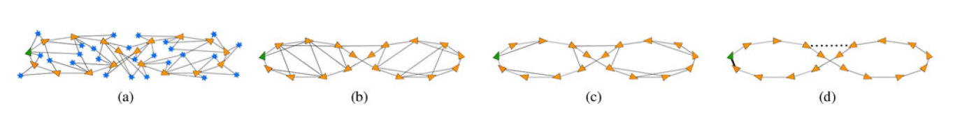

Fig. 2.1: (a) Graphical SLAM, (b) Pose-graph based SLAM, (c) Sparsely posed SLAM, and (d) Pose-chained SLAM.

From the above Fig. 2.1: The green triangle represents the first absolute posture, while the orange triangles represent all subsequent absolute poses. Blue stars indicate landmarks.

Absolute attitudes and landmarks are modelled by the graph's nodes in (a). the boundaries between the nodes in (a), which are represented by the black lines, model observations of landmarks.

In (b) and (c), the pose-edges graph's model the poses that exist between the nodes, which exclusively model absolute poses. This also applies to the pose-chain shown in (d).

However, in pose-chain SLAM, they only model edges between succeeding nodes and (loop-closing) edges that adequately describe the nodes' cumulative global error.

Only the most recent loop closure is regarded as an active edge in COP-SLAM; it is represented by the thick black line in (d). Earlier processed loop closures, such as the one depicted by the strong dashed black line in (d), are no longer actively taken into account but are instead taken into account by a filter-like mechanism inside COP-SLAM. Iterative optimizers consider all edges of the current and prior loop closures to be active edges.



Fig. 2.2: Demonstration of Closed-Form path.

From Fig. 2.2 In (a),The green triangles and green edges represent the ground-truth absolute poses and relative pose-displacements, respectively. The orange triangles and black edges provide estimations for the trajectory's absolute poses and relative pose-displacements, respectively.

The system eventually receives more precise data about its previous absolute stance, represented by the blue triangle in (b).

The first stage is to identify relative pose updates, which are represented in (b) by the tiny light grey triangles that bring the most recent absolute pose onto the desired last position, which is represented by the blue triangle. The local updates are what are referred to as. Calculating transformations, which spread out these local updates along the trajectory, is next step (c).

The dispersed updated points, which are shown in (d) by the little black triangles, are the end consequence of these modifications. Uses adjacent Pose-displacements and their dispersed updates, an improved trajectory is constructed in (d). The trajectory thus concludes in the desired absolute posture.

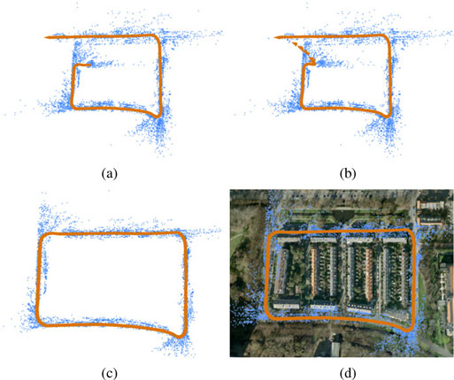

Fig. 2.3: Outputs from their monocular dataset. (a) The output of the SLAM front-end. (b) The results of 300 complete bundle adjustment cycles. (c) The results of stratified COP-SLAM, and (d) the results following the application of 100 iterations of full bundle adjustment.

The goal of the closed-form solution to trajectory bending is to transfer error at the loop-closing edge as effectively as feasible over all succeeding edges.

In large-scale scenarios where frequent loop detection is either undesired or unfeasible, it is a theoretically novel SLAM method that focuses on optimising pose-chains, which are highly sparse and locally accurate pose-graphs produced by applying visual-SLAM front-ends.

2.2 Review of SLAM++ model

The authors have outlined the key benefits of the 3D SLAM paradigm in this study, which fully exploits the fact that many sceneries contain repeating [26], domain-specific objects and structures. When a hand-held depth camera scans a challenging scene, real-time 3D object detection and tracking provides 6DoF camera-object restrictions. These restrictions are fed into an explicit object graph, which is then effectively optimised by pose-graph optimization. As a result, SLAM systems' capacities for dense surface reconstruction experience a sizable representation compression. The object graph enables both forecasts for precise Iterative Closest Point Algorithm based cameras to model tracking at each live frame and quick active search for novel objects in as-yet-undescribed picture regions. Real-time incremental SLAM in large, crowded environments has demonstrated the construction of an object-level scene description with the ability to enable interactivity, as well as loop closure, relocalization, and the identification of moved objects.

Here the authors have used an approach as shown below in Fig. 2.4.

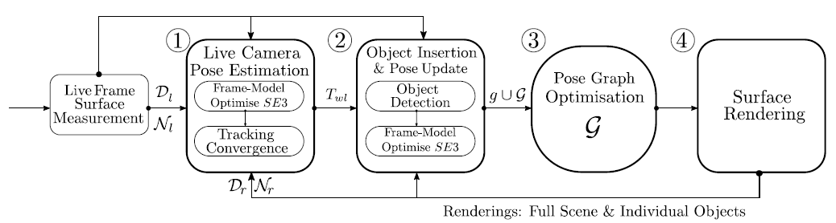

Fig. 2.4: Overview of SLAM++ pipeline

They begin by computing a surface measurement from Fig. 2.4 above in the form of a vertex and normal map Nl. This surface measurement is used as input to the camera tracking and object identification pipelines, which are then computed in sequence.

In (1), they employ an iterative closest point technique to track the live camera posture Twl using the multiple object regional prediction captured in the current SLAM graph G.

To find objects that have been previously saved in a database and are present in the live frame, they create detection candidates with an estimated pose in the scene in (2). Candidates are improved or discarded first using a second ICP estimation initialised with detected pose.

In (3), they include the successfully identified objects ('g') as object-pose vertices connected by measurement edges to the live estimated camera-pose vertices in the SLAM graph.

By rendering elements from the SLAM graph that offer a predicted depth Dr and normal map Nr into the real-time estimated frame, they allow us to actively seek only those pixels that are not characterised by the objects that are currently present in the graph in (4).

Separate ICPs between each item and the live image are run, adding a new camera-object constraint to the SLAM graph.

They use the dense ICP posture estimate and convergence check for two more crucial SLAM++ components for the Tracking of Model Initialization. The real-world objects that are employed as features are frequently confusing and difficult to distinguish from one another. Then, using the above mentioned criteria, they execute an estimate on the observed object pose given a candidate object and detected posture. This led to the discovery that for accurately detected objects, the detector's posture predictions are off by 30 rotations and 50 centimetres in translation. This enables an earlier rejection of erroneous objects and a more conservatively defined threshold.

The active set of objects recognised in SLAM++ have further been determined relative to camera based object pose parameters in order to offer constraints in the region pose graph.

Then, between each model object that is now visible in the frame and the live frame, the dense ICP estimate is performed. With the ability to create a unique relative pose estimate, it is now possible to later delete any objects that were incorrectly initialised or tracked from the pose graph.

By examining the statistics of the convergence of the camera-based item pose estimate, we may therefore maintain an inlier-outlier type count on the newly added objects.

This study has shown that it is possible to track moving objects that fail ICP gating owing to consistency, as seen in Fig. 2.5 below.

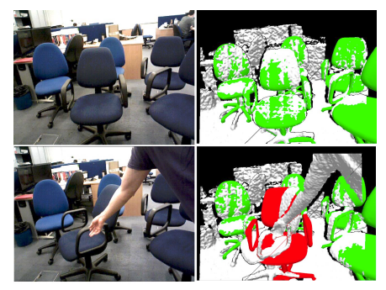

Fig. 2.5: Demonstration of moved object detection

The mapped item is designated as invalid (red) and mainly inconsistent with good measurements (green) in the aforementioned Fig. 2.5, and observations from it have been halted to prevent the rest of the graph from becoming tainted.

The authors of this study have shown that a unique real-time SLAM approach with considerable advantages in terms of effective and meaningful surrounding description is made possible by incorporating high performance three-dimensional object recognition in the loop. They notably demonstrate how everyone benefits from the close coordination of the recognition, mapping, and tracking aspects.

2.3 Review of a Robust and Efficient RGB-D SLAM in Dynamic Environment

In this study, the authors offer an RGB-D SLAM system that can operate in real-time on a single dual-core CPU in dynamic settings. A dynamic keypoint exclusion mechanism [27] with three phases forms the basis of this system.

1) Dividing keyframe pixels into areas based on their relationships to space and appearance.

2) Determining dynamic regions by examining the motion consistency of each region's keypoints.

3) Removing important locations from both the 3D local map and the identified dynamic zones.

Any keypoint-based RGB-D SLAM system can easily incorporate this dynamic keypoint exclusion method to enhance accuracy and resilience in dynamic settings with a negligible time increase.

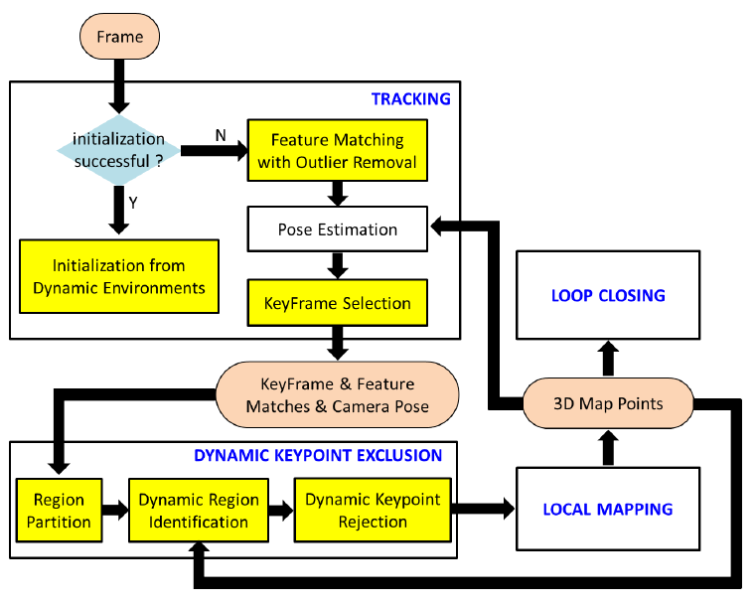

Fig. 2.6: The framework of the proposed system based on ORB-SLAM2.

1. Initialization from Dynamic Environments:

The traditional RGB-D SLAM technique is as follows for setting up the local map and camera positions. The first local map is produced by displaying the two-dimensional key points of the first keyframe to the 3D space based on their depths. The first frame is used as the keyframe.

Then, by initially looking for matches between key points in the current frame and nearby map points, the initial pose of the current frame in relation to the first keyframe is approximated. This is done by applying Perspective to n-Point (PnP) to the matches.

The subsequent pose estimation and mapping are significantly impacted by this initialization performance. Such an initialisation technique could, however, include dynamic points in the initial local map without any method to manage dynamic points, leading to unreliable matches in the following pose estimate.

2) Keyframe Selection:

If each of the following three circumstances holds true, keyframe:

1. The dynamic keypoint exclusion module is static, or more than 20 frames have satisfied the criterion from the most recent keyframe insertion.
2. At least 50 points must have been tracked on the current frame.
3. The current frame tracks must be less than 90% of the points of the reference keyframe.

The original ORBSLAM2's conditions I and II, and III apply. Accurate relocalization and tracking are ensured by conditions I and II. To increase mapping accuracy through triangulation, condition III imposes minor visual changes between the present frame and the key-frame. To lessen the negative effects caused by our DKE module's miss detection of dynamic points, condition I is proposed.

DKE is carried out on each keyframe, therefore choosing a new keyframe if more than 20 frames have been passed since the previous keyframe may limit the number of incorrectly detected dynamic points that are added to the local map while also starting the DKE (thread for determining dynamic point).

They have contrasted the management of dynamic regions in terms of runtime between their approach and DS-SLAM. DS-SLAM processes only keyframes, whereas this technique recognises and filters out moving objects for every frame. They have calculated the average duration per frame for two approaches and documented the total time for executing a whole sequence as a point of comparison. The comparison findings are shown in Table 2.1, where their technique handles moving objects much faster than DS-SLAM.

This is such that non-trivial and redundant calculation for efficiency is avoided by their carefully constructed DKE approach, which makes use of the intermediate results obtained from the ORBSLAM2 system.

Table 2.1: Comparison of DS-SLAM with DKE-SLAM

|  |  |  |
| --- | --- | --- |
| Modules | Time (ms) | GPU Support |
| Region Participation (DS-SLAM) | 29.50 | Yes |
| Region Participation  (Proposed DKE SLAM) | 15.61 | No |
| Dynamic region (DS-SLAM) | 37.57 | No |
| Dynamic region (Proposed DKE SLAM) | 0.99 | No |

Dynamic Keypoint Exclusion: It is based on the idea that dynamic key points are distributed unevenly throughout a frame, as opposed to being spread regionally. Therefore, if the majority of keypoints in a region are determined to be dynamic, the remaining key points in that region should be very likely to be dynamic and unreliable for camera pose estimation.

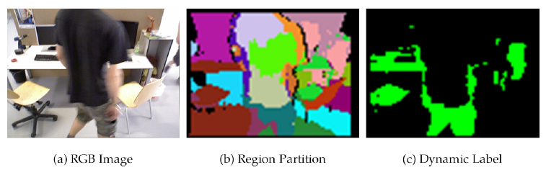

Fig. 2.7: (a) A RGB image, (b) the outcome of region partition, and (c) regions that have been classified as dynamic due to occlusion from individuals walking by.

This method considerably outperforms or is on par with the majority of the most advanced dynamic RGB-D SLAM systems, according to experimental results on open datasets. It is also significantly more efficient than DSSLAM. Even if they simply incorporate the DKE module into ORBSLAM2 in this work, RGB-D systems based on keypoints can all be connected with ease.

A closer look reveals that this approach might not be able to provide accurate tracking if the number of dynamic points reaches half the total number of points on a frame. This is due to the fact that if more than half of the points are on dynamic objects, it may be difficult for our system to determine whether the poses calculated for the current frame are valid.

Inaccurate posture estimation may lead to unsuccessful removal of dynamic points and consequent tracking and mapping problems for the succeeding frames. For such extremely dynamic instances, combining semantic segmentation with this approach may be an option.

For dynamic settings, the authors of this study offer an efficient RGB-D SLAM built on top of ORB-SLAM2.

The authors contend that, unlike most existing systems, the dynamic region identification approach does not require the use of sophisticated semantic segmentation techniques for region partition.

**CHAPTER 3**

**METHODOLOGY**

3.1 Block Diagram

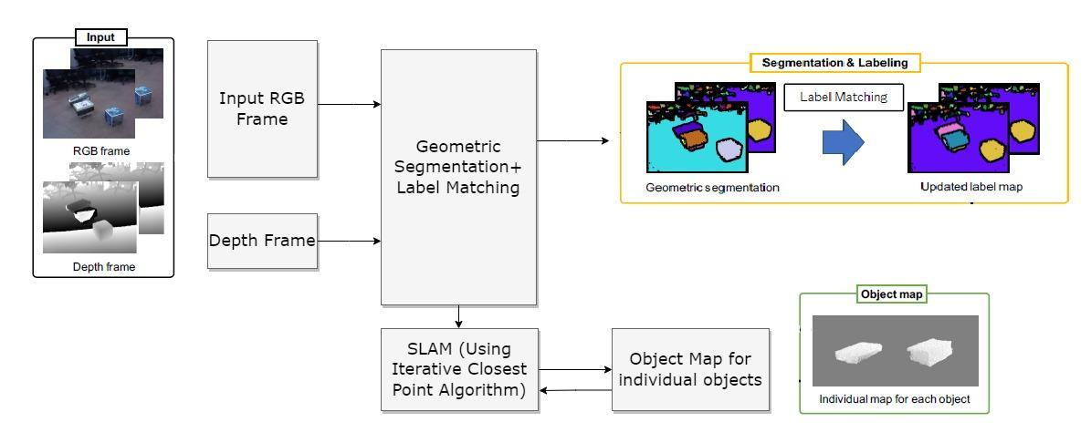

Fig. 3.1: Above is block diagram representation of the proposed SLAM based algorithm to be used in the project.

As proposed in every SLAM based approach the key to processing algorithms in Augmented Reality applications focuses on obtaining appropriate inputs from sensors or using variety of cameras i.e monocular, RGB, RGB+Depth based camera, IR, Laser and even in some extent the use of Hyperspectral Cameras for data inputs collection purposes. This however will vastly affect the methodology followed by SLAM and its feedback based processing used for obtaining maps.

In our proposed SLAM we will be making use of majorly the RGB+Depth inputs as they are widely available for use in large number of datasets, this is also the most commonly used data inputs available from as simple as mobile cameras to high end with best quality of RGB+D based cameras. Also the existing applications and developers of SLAM ,use the Microsoft Kinect Camera which is a popular input source. The 3D sensor data inputs referred in this project is thus basically RGB+Depth information provided by the camera sensor.

3.1.1 Geometric Segmentation

Geometric Segmentation [8] is basically a pre-processing technique employed for computation purposes. Here we make use of Histogram Equalisation [5] based techniques along with a special Histogram Equalisation method for its betterment. This process when completed will give us an updated label map obtained after processing, also later we shall move onto the main processing of ICP [14] based SLAM which is playing a key role in obtaining the mapped outputs.

Let us delve into the Geometric segmentation processing part:

A computer image processing method called Histogram equalisation is used to enhance contrast in photographs. It achieves this by effectively extending the intensity range of the image, as illustrated in Fig. 3.2, and effectively spreading out the most frequent intensity values. When the useful data is represented by close contrast values, this strategy typically boosts the overall contrast of the photos. This makes it possible for regions with less local contrast to acquire more contrast.

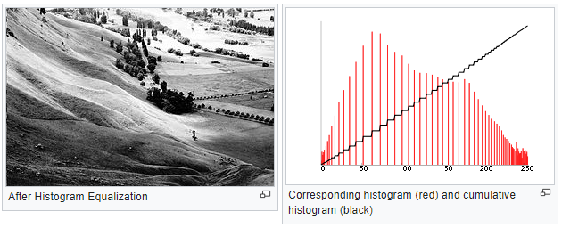

Fig. 3.2: (Left) Raw image after HE processing (Right) Histogram representation of Raw image.

The number of pixels in each sort of colour component is shown in an image's colour histogram. Red, Green, and Blue components of the image cannot be individually subjected to histogram equalisation [6] since doing so would drastically alter the image's colour balance. The procedure can be used to the illuminate without affecting the image's hue and saturation, though, provided the image is first translated to a different colour system, such as the HSL/HSV colour space.

A sample image of the crater on moon was taken as reference for experimenting the different equalisation approaches, the images are different in contrast settings to potentially observe which equalisation approach is better for retrieving maximum of image characteristics after processing is done.

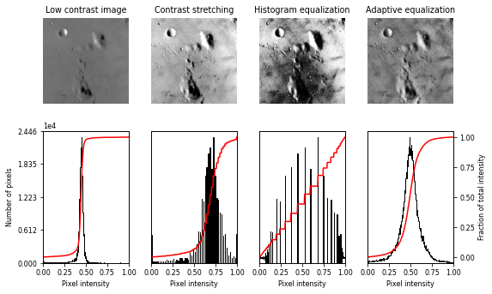

Fig. 3.3: The four images from left represent a low contrast, contrast matching, Histogram Equalisation and Adaptive equalisation techniques.

From the Fig. 3.3 we can observe that HE [1] and Adaptive Equalisation techniques spread out intensity ranges of the image which makes it useful for Localization approaches. Adaptive Equalisation is an improved version of HE [2], [7] method obtained as we can observe a continuous curve which represents the contrast of the Raw image exactly as seen from the original image.

Moving on, the Contrastive Limited Adaptive Equalisation (CLAHE), which is based on Adaptive Equalisation, differs from Adaptive Histogram Equalisation in that it limits contrast. In the case of CLAHE [4], [15] the contrast limiting technique is applied to each neighbourhood from which a transformation function is derived. Adaptive histogram equalisation could result in excessive noise amplification, CLAHE [4] was developed for this sole purpose.

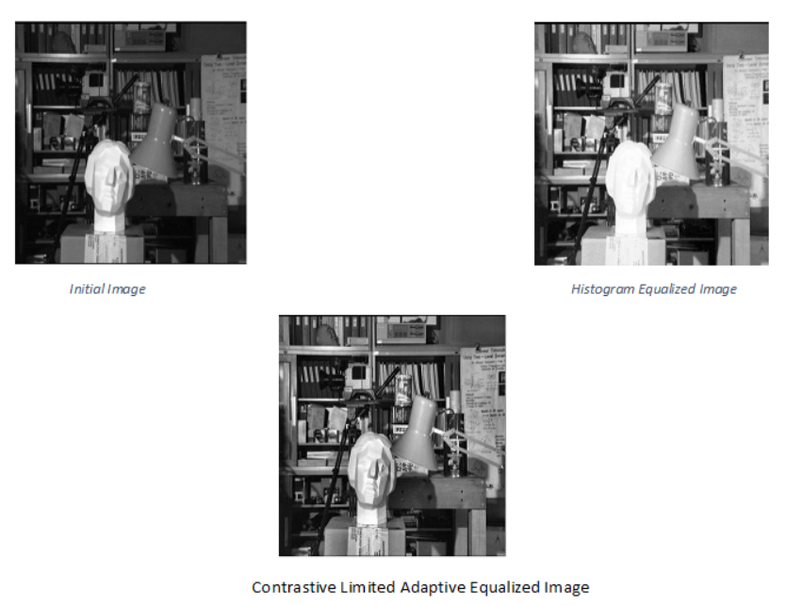

Fig. 3.4: Picture on the left top corner represents the raw image for which the CLAHE and HE processing is done.

Further processing was done on black and white images for proving the approach is much better than the pre existing SLAM approach which does not comprise any pre-processing methodologies.

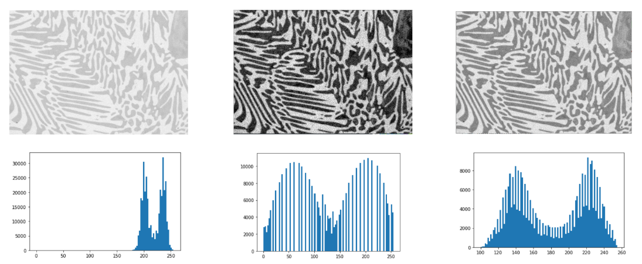

A B C

Fig. 3.5: A-depicts RAW image with histogram, B-depicts HE image with histogram, C-depicts CLAHE image with histogram.

In the above image Fig. 3.5, we introduce a dark image enhancement based on Contrast Limited Adaptive Histogram [1], [3].

The RGB image is converted into HSV colour space, from that image intensity component is extracted and it is normalised.

Intensity components contain extremely dark pixels and when intensity value is enhanced, pixel noises will be introduced.

So we take the inverse of the intensity component before removing the noise.

The Contrast Limited Adaptive Histogram Equalisation (CLAHE) [1] is applied to the inverse of the intensity component, thus it enhances the image.

This method can be efficient for real time extremely dark image enhancement applications.

3.1.2 Iterative Closest Point Algorithm

The difference between two clouds of points is minimised using an approach known as Iterative Closest Point (ICP). ICP is commonly used to map the environment, find robots, and recreate 2D or 3D surfaces using data from many scans.

ICP can be explained as follows:

In general, the ICP algorithm performs with below conditions:

1. From the target point cloud P and the source point cloud Q that have been changed with the current transformation matrix T, we can find the correspondence set K=(p,q).
2. By minimising an objective function E(T) that is specified over the correspondence set K, update the transformation T.

The correct relative rotation and translation can be determined in closed form if the correct correspondences are known.

In general [16], [18] it is impossible to establish the best relative rotation or translation in a single step in the absence of correct correspondences. In this case, the algorithm will keep iterating the points until it gets the final closest alignment and checks a condition whether the starting points are converging with the final points and if they are also close enough the algorithm [17] terminates the iterations, by this way the algorithm will be capable of handling the point to point iterations [15] in a smooth and fast manner, also these parameters of iterations are not required to be set as input parameters by any means.

Essentially, the algorithm (ICP) steps are:

1. Finding the reference point cloud's nearest neighbour for each source point cloud point (either the full dense set of vertices or a sample of pairs from each model's vertices) (or a selected set).
2. Estimate the rotation and translation that will best align each source point to the match found in the previous stage using a root mean square point-to-point distance metric minimization technique. This technique may also include weighting the points and removing outliers before alignment.
3. The processing of images following transformations is shown in Fig. 3.6 by applying the acquired transformation to the source points.
4. Iterations (re-associate the points, and so on).

Thus to confirm the approach of the ICP algorithm, we have performed some experiments on 3D images which provide us adequate results for its use into the proposed SLAM design.

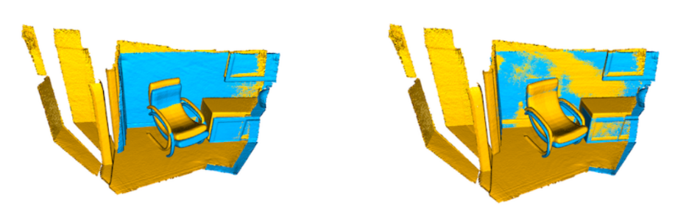

A B

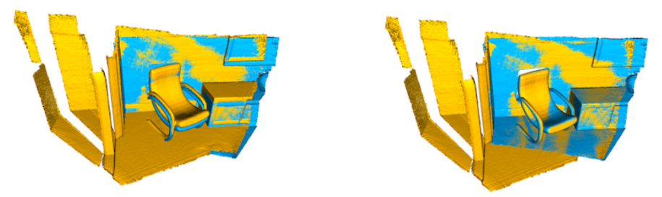

C D

Fig. 3.6: A-Input image (source points-yellow, and Target points-cyan), B-Point to Point ICP output after 30 iterations, C-After ICP output 30 iterations , D-Point to Point ICP output after 144 iterations.

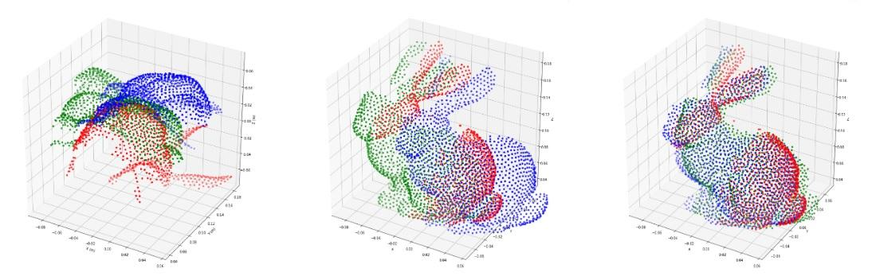

A B C

Fig. 3.7: A-shows the input point clouds, B-shows the updated axis and C-shows final projected output for point to point ICP.

3.1.3 SLAM Approach

As discussed above this proposed SLAM model makes use of ICP-SLAM the key resources of SLAM are integrated in packages available in an open source repository available for developers to tinker around for AR/VR applications.

Here in our model we make use of MRPT and RTAB_map_ros packages available for use.

The key intended purpose is to integrate each block of operation as discussed in the block diagram the Geometric Segmentation blocks are pipelined with ICP-SLAM available from the packages thus making our functionality feasible. However it is not a task to be performed at ease as the scenario could cause complications if the constants of pre-processing are wrongly fed to proposed SLAM packages. It is necessary to integrate all the blocks in segregated code bases along with individual launch files for viewing outputs.

The proposed SLAM provides localisation maps simultaneously and we can observe them as and when the data inputs are processed sequentially.

Let us look into the packages for further understanding of building the proposed SLAM model.

I. MRPT package:

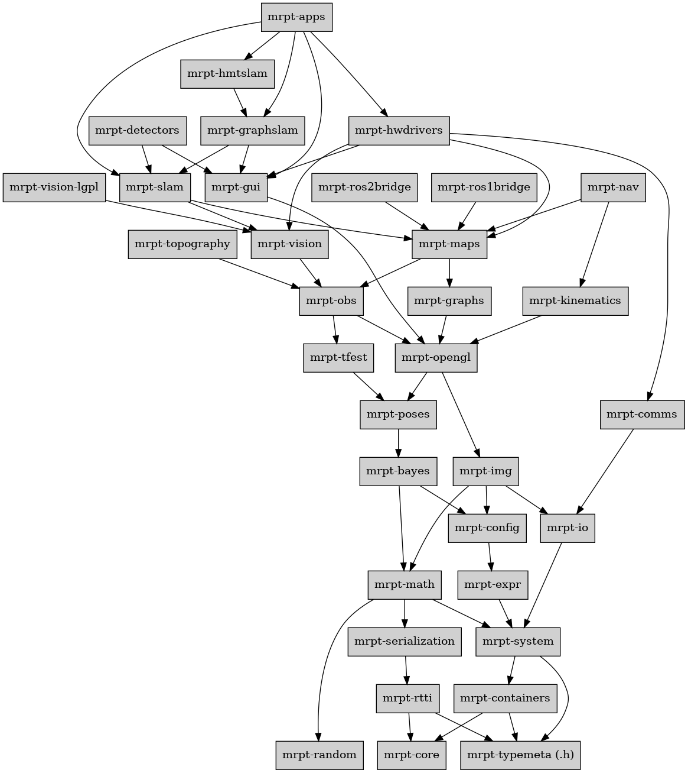

Fig. 3.8: The MRPT package along with its libraries

We make use of the following libraries:

## Mrpt-maps: The majority of the maps that can be used for localization or mapping in the remaining MRPT classes are contained in this library.

## Mrpt-graphslam: The maps needed to create graphical user interfaces are included in this library.

## Mrpt-core: This library includes the core SLAM algorithm.

II. RTAB-map package:

The RGB-D [23] Graph SLAM method known as RTAB-Map is based on a global Bayesian loop closure detector (Real-Time Appearance-Based Mapping). The bag-of-words technique is used by the loop closure detector to identify whether a fresh image is more likely to come from a new or old site. When a loop closure hypothesis is confirmed, a new constraint is added to the map's graph, and a graph optimizer then minimises the map's errors.

The quantity of locations needed for loop closure detection and graph optimization is further constrained by a memory management method in order to constantly respect real-time constraints for large-scale settings.

For 3DoF mapping (2D LiDAR) and 6DoF mapping [21], RTAB-Map has the benefit of being utilised on a robot with a laser rangefinder, or by itself with a portable Kinect or stereo camera for 6DoF RGB-D [22] mapping (3D LiDAR). However, we can illustrate the technique using our pre-existing datasets of video recordings of rooms and surroundings.

3.2 Hardware Requirements

This proposed project focuses on making accessible/portable SLAM for normal computing applications and thus there is not a vast requirement of higher processing resources, however the approach requires an adequate enough graphics processor for mapping and localisation purposes.

However it was tested on the latest computing resources available to us which is Intel i7-11800H processor running at maximum of 2.3GHz and GPU of NVIDIA GeForce RTX 3050 Ti.

The packages used in the proposed approach have been used to run in lower end GPUs too thus giving us an edge into creating the proposed approach with a simple workstation accessible to users.

3.2 Software Requirements

This project is built on Ubuntu operating System (20.04 LTS Version) with the packages which most developers of AR and VR make use , following are the softwares used in the project:

1. RVIZ is a 3D visualisation software application for robotics, sensors, and algorithms (sometimes known as "ROS visualisation"). It allows us to observe how the robot sees the outside world (real or simulated). Rviz's goal is to make it possible for you to visualise a robot's status. It makes an effort to accurately represent what is happening in the robot's environment using sensor data.
2. Gazebo: Gazebo is a 3D robot simulator that can compute forces like gravity as well as simulate a robot to give us a good idea of how it would act in a given environment.
3. The Robot Operating System (ROS) is a combination of free and open-source software tools and libraries that enables us to create robot applications.
4. VS code: VS code (Visual Studio Code) is the code editor which has been used for building codebase and launching the project.

3.3 Implementation

As discussed above the proposed SLAM project is built with the blocks comprising of pre-processing and ICP-SLAM which provides us the object map for the respective data inputs these are carefully integrated using all the packages and softwares into the code base to provide us with the mapping outputs which can be viewed from simulators respectively, also the key dependency of having GPU has been useful for rendering the mapped environments specifically.

**CHAPTER 4**

**RESULTS & DISCUSSION**

In this section we shall have a look of the processed outputs and its analysis:

4.1 MRPT based approach :

As discussed the outputs for the MRPT based approach is as follows:

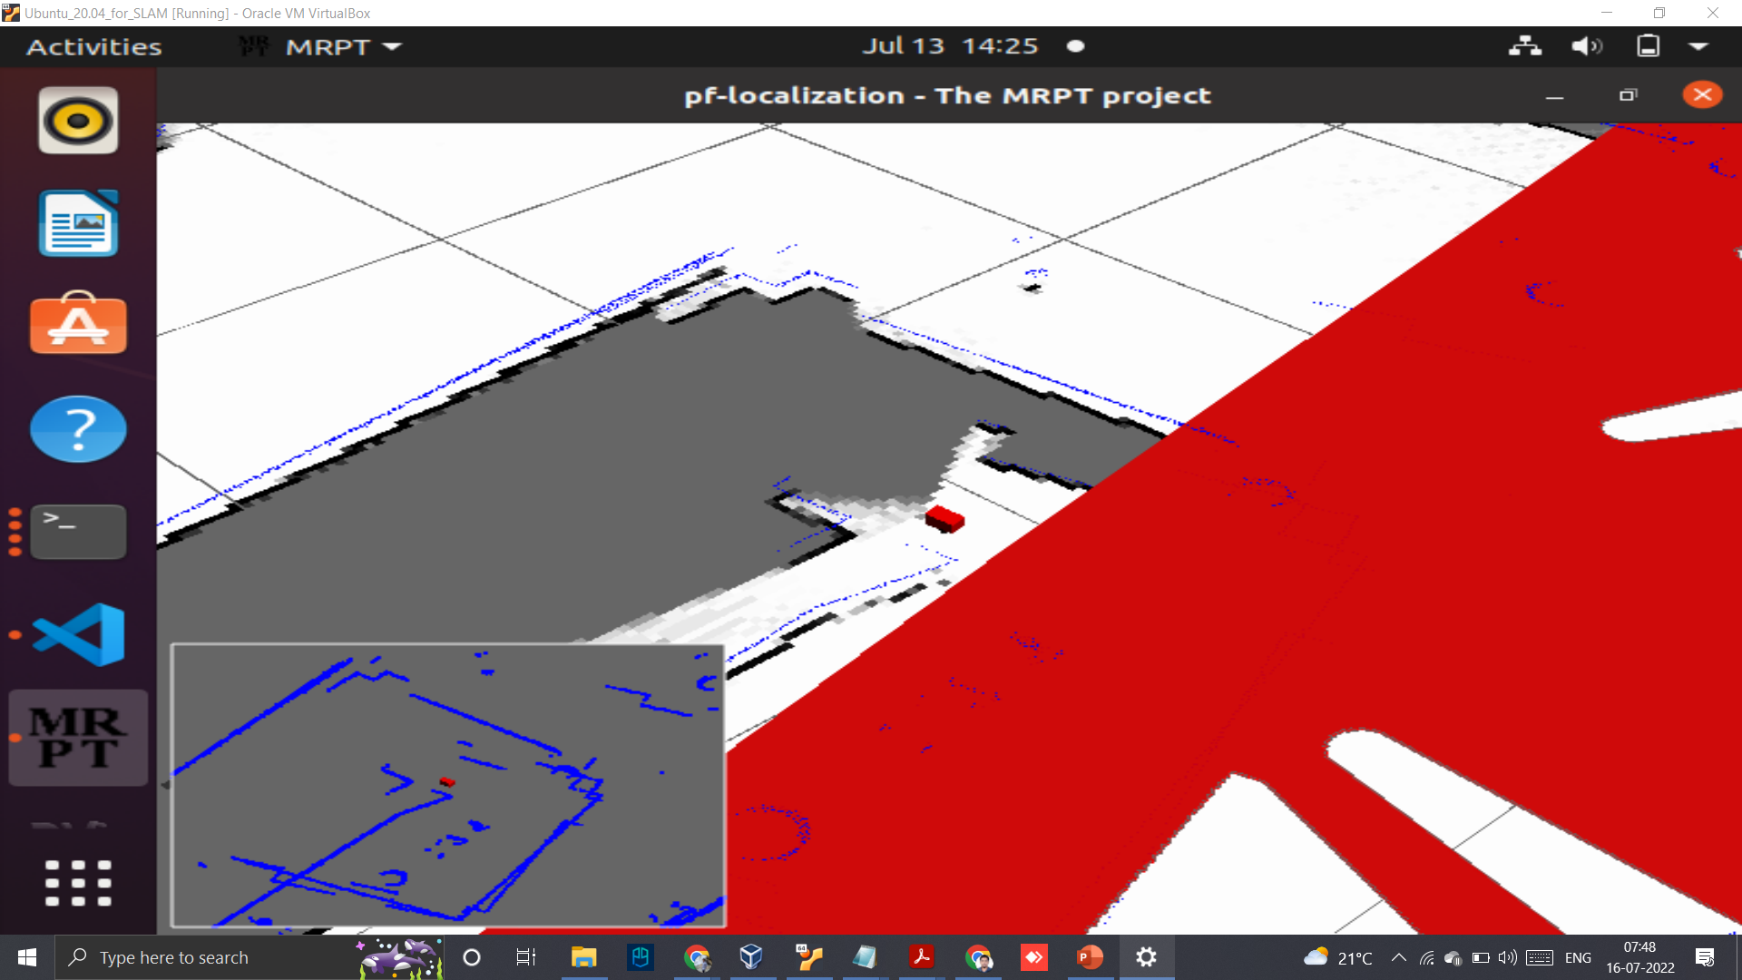 

A B

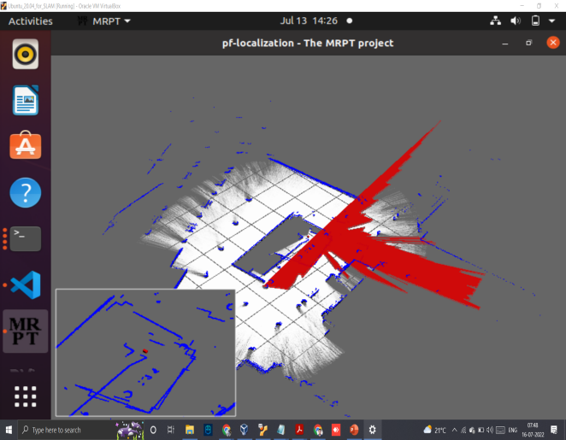 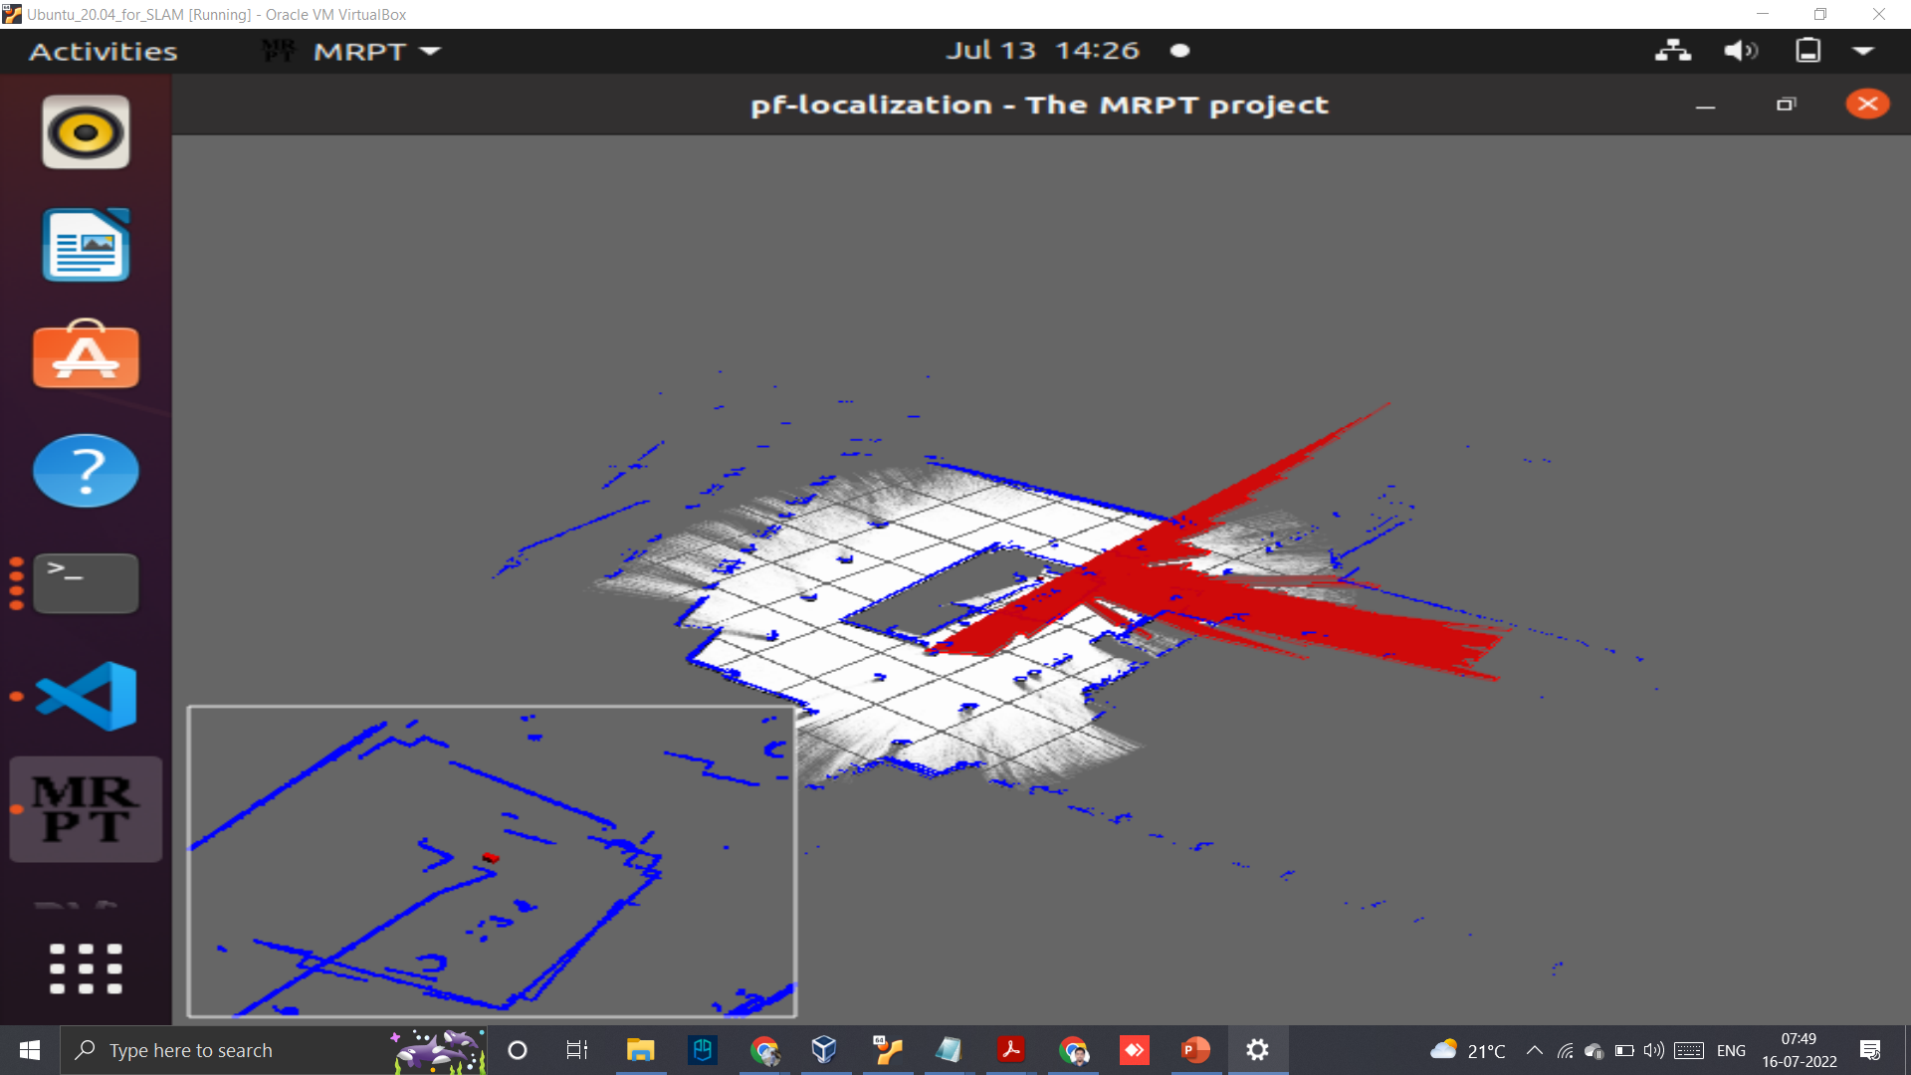

C D

 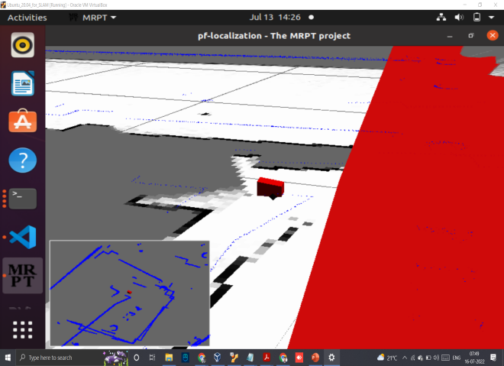

E F

Fig. 4.1: All of the images from A to F shown, represent the mapping of the robot on a customised environment, The bottom left corner shows the mapped edges detected using the proposed SLAM approach. The final image F represents the final point after the robot transversed the environment in a single loop.

4.2 RTAB Mapping Approach:

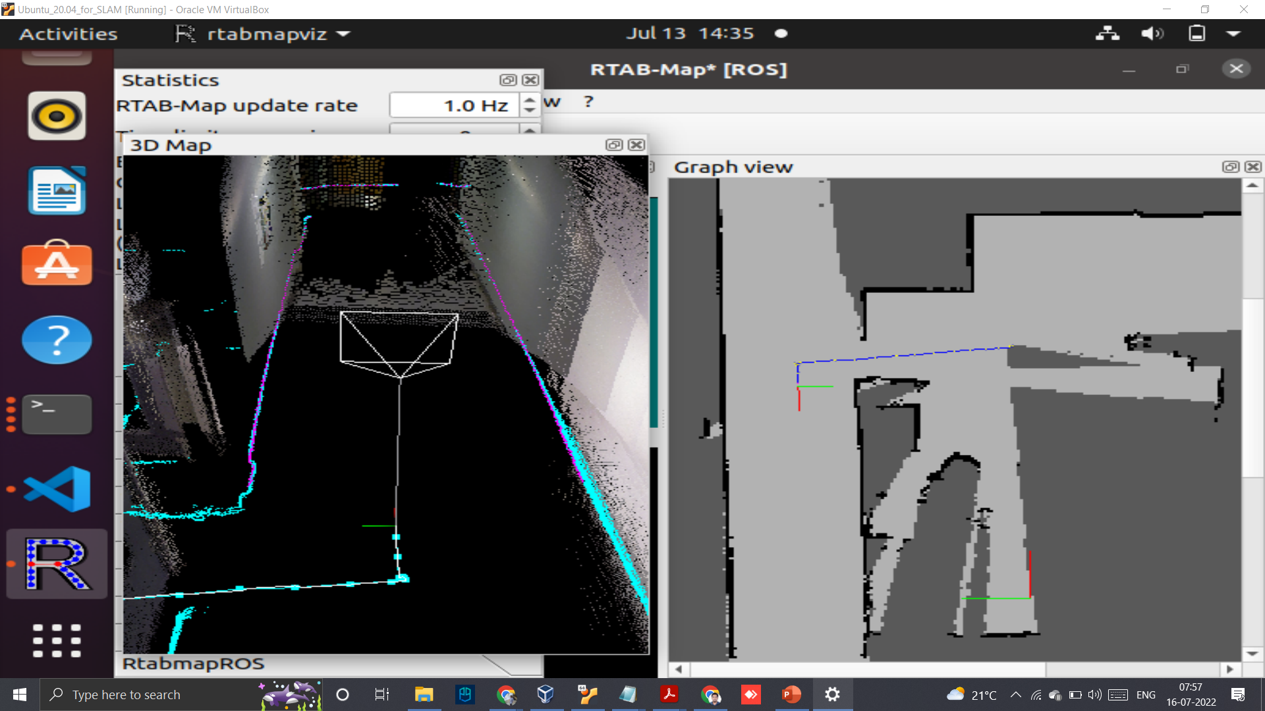

Fig. 4.2: In the above image the robot starts to move around a Laboratory, which plots the 3D mapping along with the graph view of path traversed.

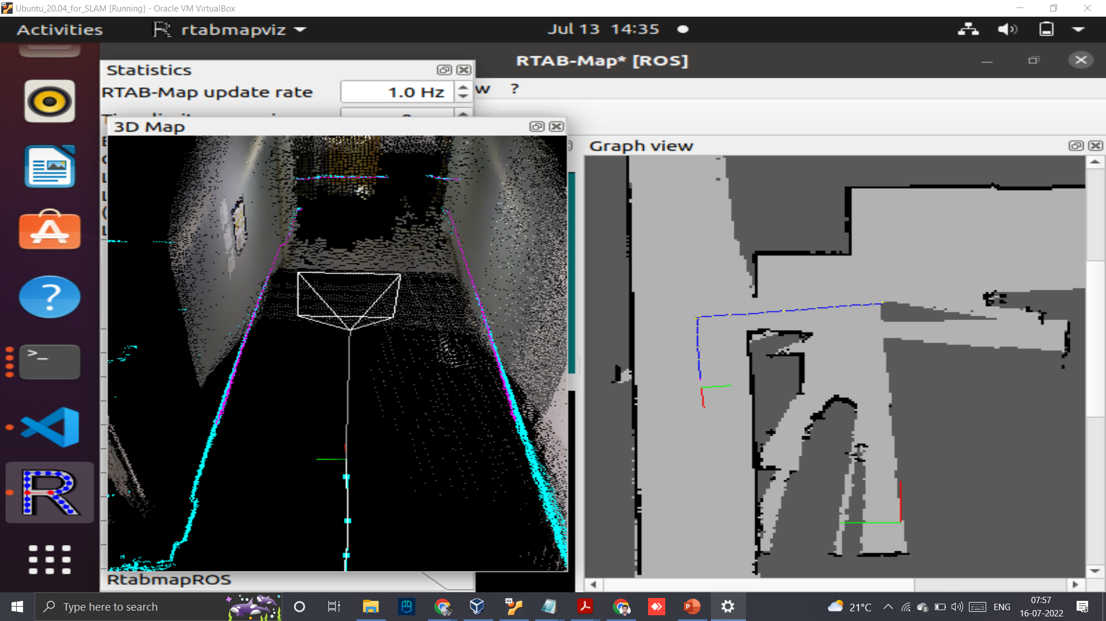

Fig.4.3: We can see the movement of robots has changed in comparison to Fig. 4.2.

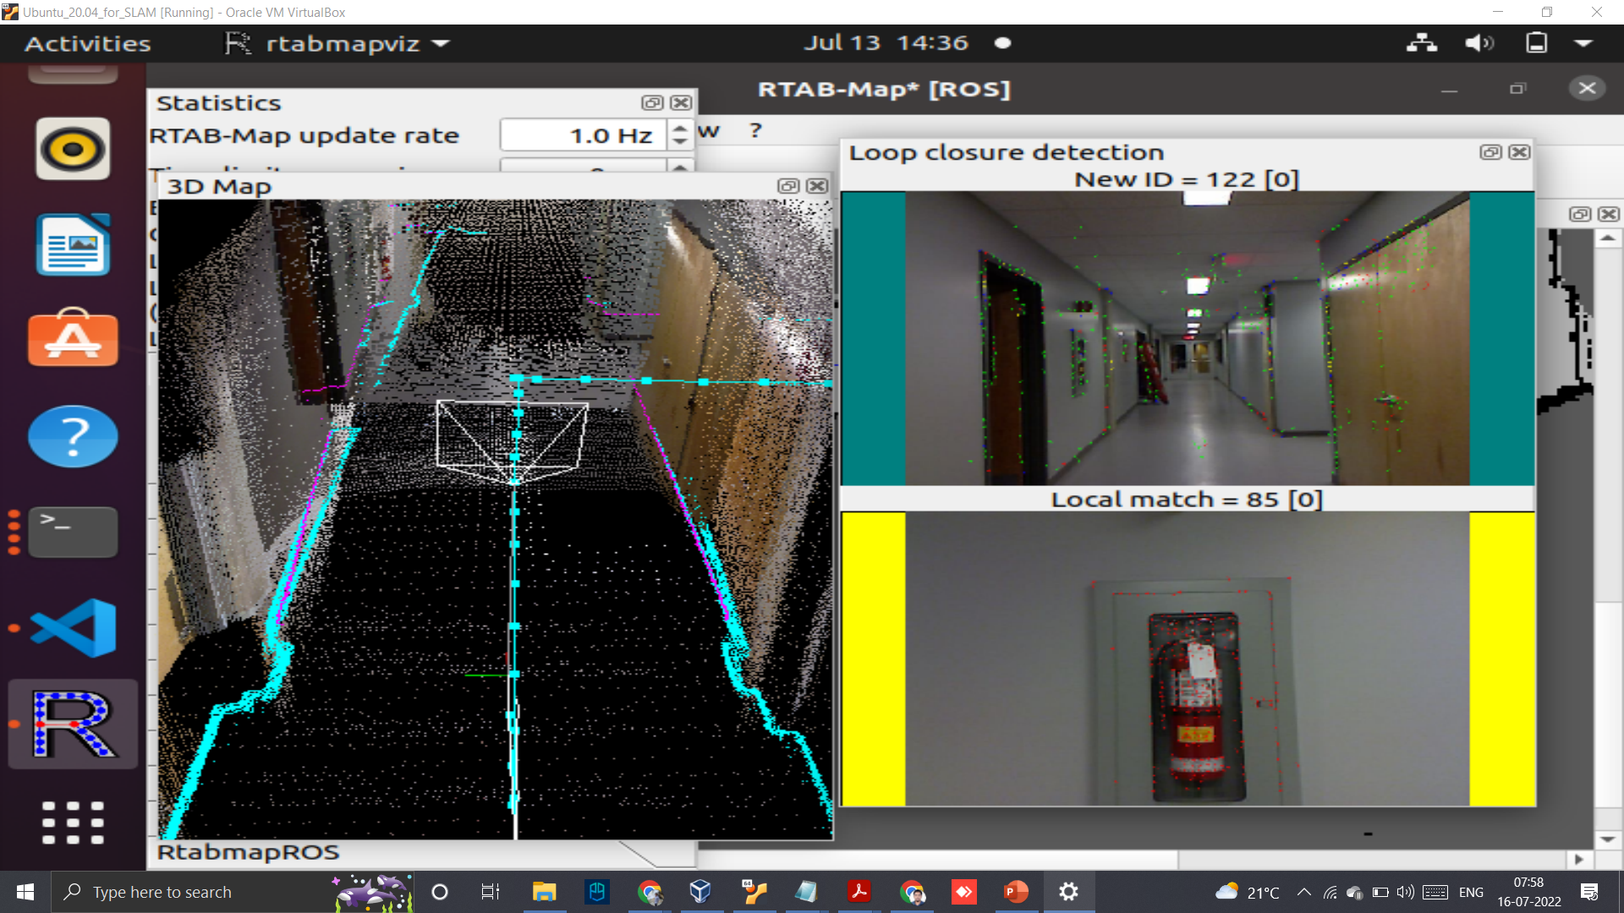

Fig. 4.4: Above image shows even clear 3D point clouds that are visible while the robot maps around the Lab, the right side of the image represents the loop closure detection with respect to the live scene detected.

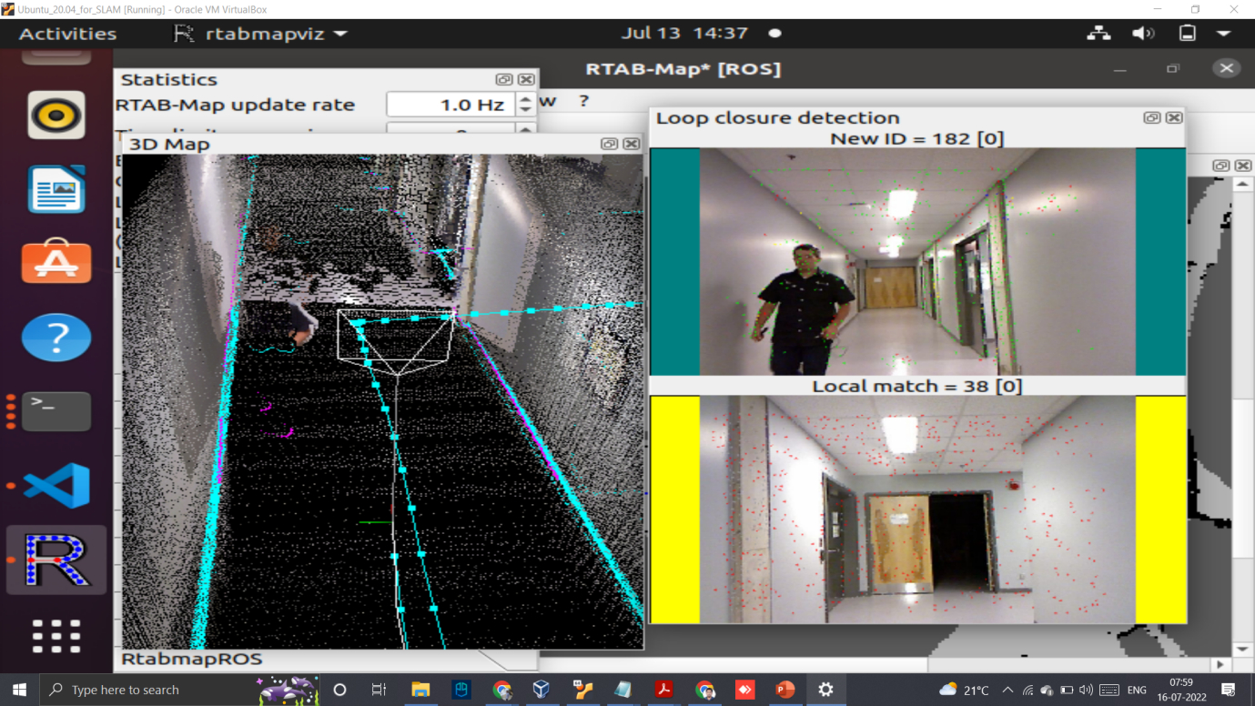

Fig. 4.5: Above image shows that even unknown objects are mapped 3D point clouds that are visible while the robot maps around the Lab, also on detection of humans it makes a live map and avoids the person.

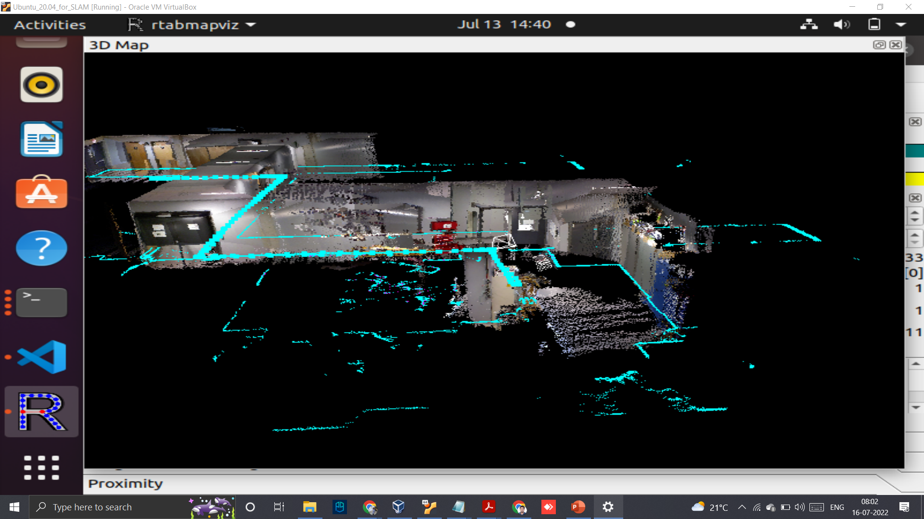

Fig. 4.6: Above image shows the mapped Laboratory which is saved after the mapping is complete, we can have a look around the mapped locations and perceive the mapped individual objects.

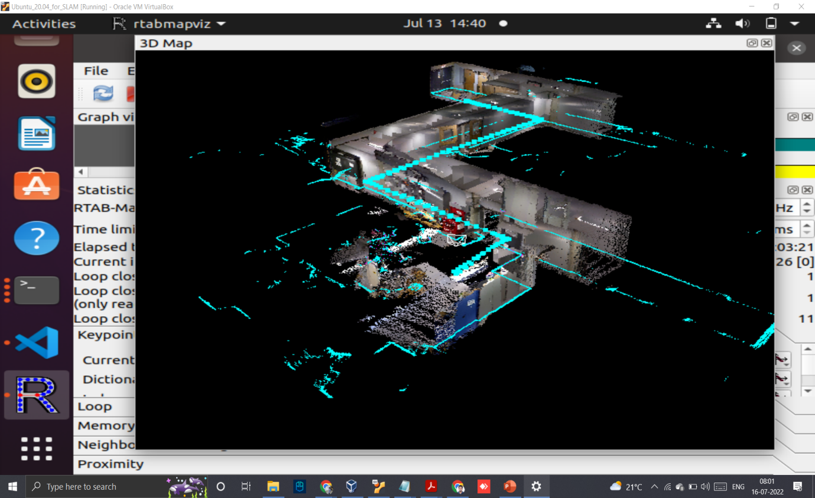

Fig. 4.7: Above image shows another sample of the mapped laboratory.

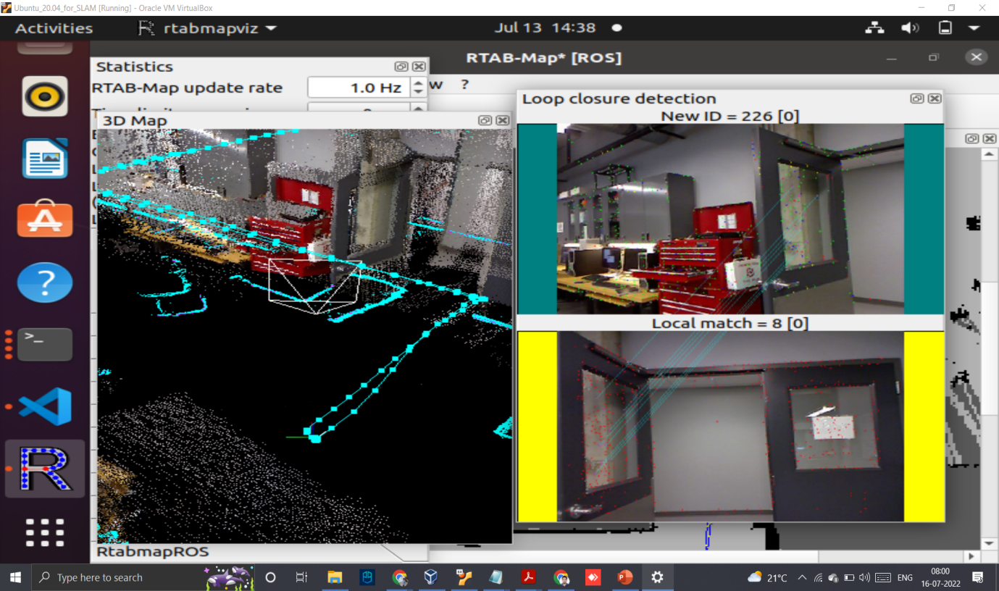

Fig. 4.8: Above image shows the final point after the robot stops mapping.

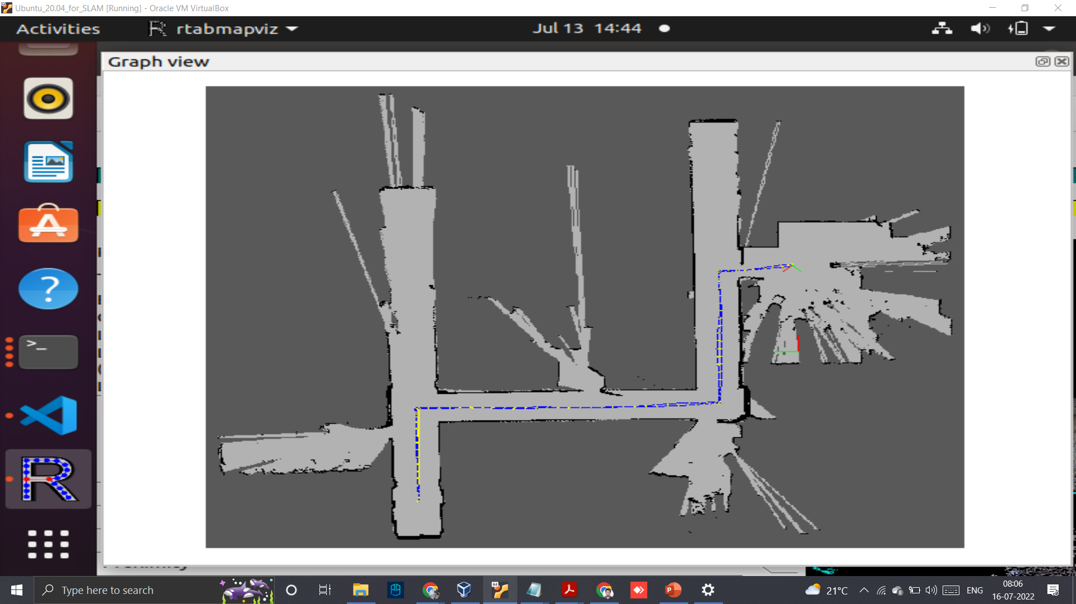

Fig. 4.9: Above image shows the graph view outputs after mapping.

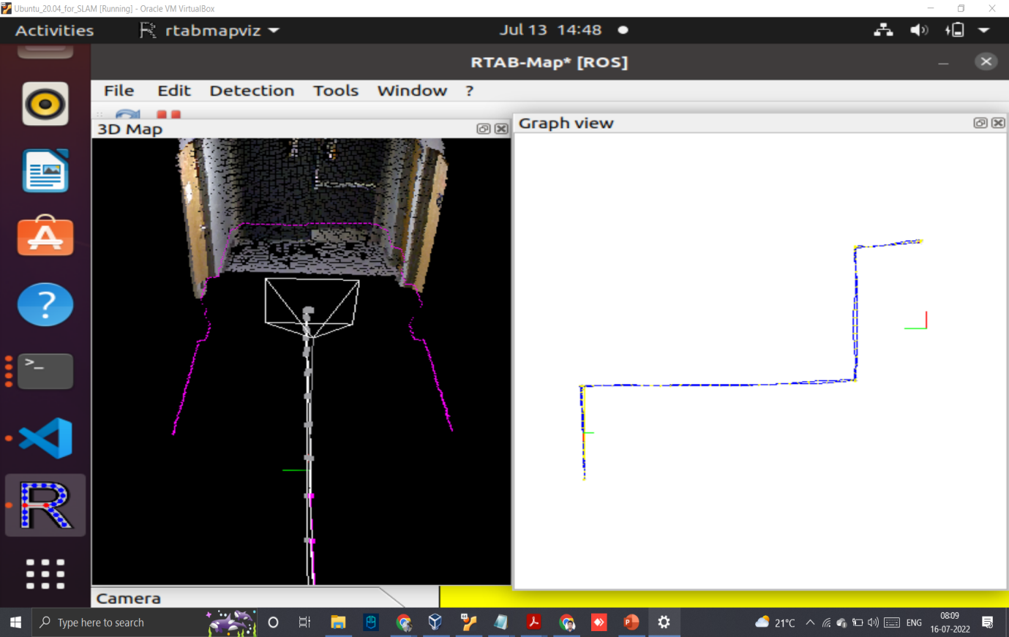

Fig. 4.10: Above image shows the graph view localisation of the robot initially on traversing through the path outputs during mapping.

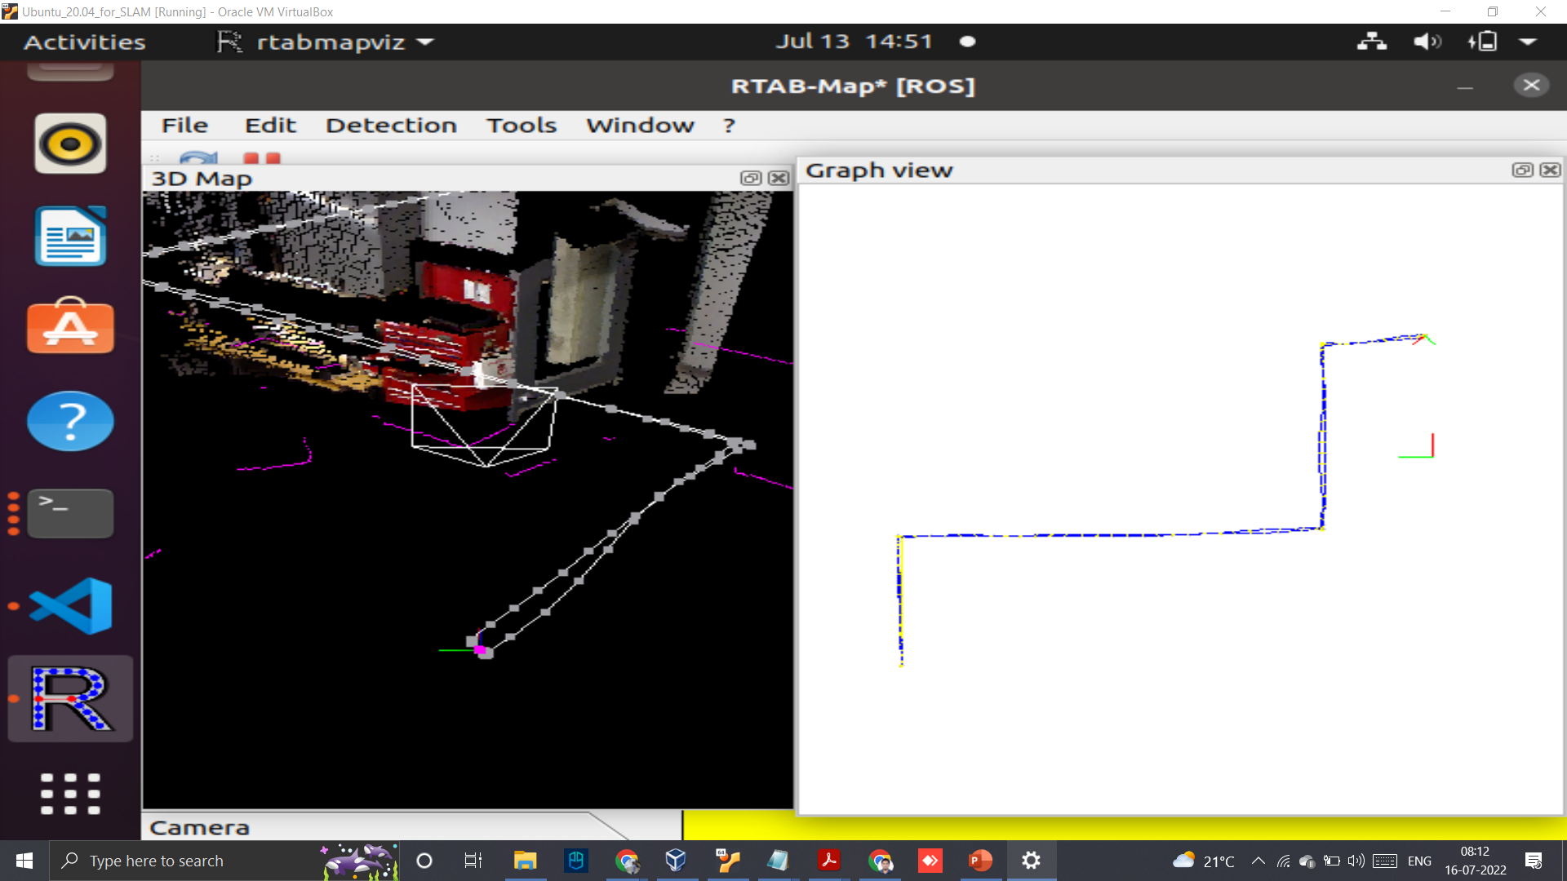

Fig. 4.11: Above image shows the graph view localisation of the robot in the final point after finishing the path outputs after mapping.

Table 4.1: Representation of performance metrics obtained from the mapping responses

|  |  |  |
| --- | --- | --- |
| Testing method | Execution time | Execution rate (Hz) |
| ICP-SLAM (Point matched) | 1.39 ms | 773.68 Hz |
| ICP-SLAM (Grid matched) | 1.80 ms | 569.34 Hz |
| Point-map (10 Iterations) | 1.63 ms | 588.12 Hz |
| Point-map (50 Iterations) | 41.80 ms | 20.82 Hz |
| Hypot_Fast (Float variable) | 3.93 ns | 253.47 MHz |
| Hypot_Fast (Double variable) | 5.31 ns | 191.72 MHz |

From Table 4.1, we observe the MRPT functions of both float and double functions are executed at faster sampling speed while ICP SLAM is at slower frequency but the execution time is much slower too, this proves that the SLAM based approach has been faster in terms of execution time.

We have compared the results with a Scan mapping approach with Dynamic Likelihood function [24] and our model which uses ICP-SLAM based approach for its mapping outputs, we have seen that our results are 82% faster (Table 4.2.) in comparison to the same. Also our approach is able to create live loop closure detection along with localisation graphs of the mapped regions successively for processing video data.

The SLAM model also has sufficiently faster image processing speeds in comparison to Scan mapping approach with Dynamic Likelihood function with SLAM, the images can be processed from sizes of 160x120 pixels to upto 1280x1024 pixels sizes for 2D image mappings respectively.

Table 4.2: Comparison of execution times

|  |  |  |
| --- | --- | --- |
| Dataset of building mapped | Scan mapping approach execution time (ms) | Histogram equalisation approach execution time (ms) |
| ACES | 7.2 | 1.27 |
| Intel | 3.61 | 1.63 |
| CSAIL | 11.51 | 1.19 |
| FR079 | 7.62 | 1.48 |
| Avg Execution time = | 7.485 | 1.39 |

**CHAPTER 5**

**CONCLUSION & FUTURE WORK**

A Histogram equalisation based ICP SLAM was proposed with an improved pre-processing compared to existing SLAM approaches and variety of images and simulations were performed on sample and 3D data sets of inputs and the performance metrics proved to be faster in terms of execution time and its approach was analysed, This approach of pre-processing has been useful in retaining the portions of the images along with edges, contrast and smoothness was observed to be intact. This approach has been built with sophisticated mobile robot softwares available for use with various SLAM developers and thus helping contribute to various approaches which could be of use for numerous applications involving mapping objects in a dynamic environmental setting while the objects are in motion with respect to surroundings.

The above approach could be infused into applications receiving split second decision outputs for spatial mapping and could me made of use in household electronics to military level applications providing an accurate environment region mapping, also giving an enhanced after processing block from the pre-processing method proposed could give more insight into making an even faster system which could be taken up for the future.

The proposed model is suitable for portable and affordable computers for performing various 3D mapping applications.

**REFERENCES**

1. Farah F. Alkhalid, Ahmed Mudher Hasan and Ahmed A. Alhamady., “Improving radiographic image contrast using multi layers of histogram equalization technique,” IAES International Journal of Artificial Intelligence (IJ-AI)., Vol. 10, No. 1, pp. 151-156,  March 2021, doi: 10.11591/ijai.v10.i1.pp151-156.
2. Cui Z., Wu J., Yu H., Zhou Y., Liang L., “Underwater Image Saliency Detection Based on Improved Histogram Equalization,” In: Mao R., Wang H., Xie X., Lu Z. (eds) Data Science. ICPCSEE 2019. Communications in Computer and Information Science, vol 1059. Springer, Singapore. 2019.
3. Ebele O., Ikechukwu O., Hycinth Inyiama., “Performance Evaluation of Histogram Equalization and Fuzzy image Enhancement Techniques on Low Contrast Images,” International Journal of Computer Science and Software Engineering (IJCSSE), Volume 8, Issue 7, July 2019.
4. Farah F. Alkhalid., “Expansion Dataset COVID19 Chest X-Ray Using Data Augmentation and Histogram Equalization,” International Journal of Electrical and Computer Engineering (IJECE), 2020.
5. Ali MN, Abdullah-Al-Wadud M., “Image Enhancement Using a Modified Histogram Equalization,” In Computer Applications for Web, Human Computer Interaction, Signal and Image Processing, and Pattern Recognition, 2012 Nov 28 (pp. 17-24). Springer, Berlin, Heidelberg.
6. Sonal R., Saswat R., Sanjay K., “A improved Histogram Equalization Technique for Image Contrast Enhancement,” International Conference on Communication and Computing (ICC-2015), Alpha College of Engineering, Bangalore, Karnataka, 9-11 July 2015.
7. Khanh Nguyen-Trong and Hoa Tran-Xuan., “Coastal forest cover change detection using satellite images and convolutional neural networks in Vietnam,” IAES International Journal of Artificial Intelligence (IJ-AI)., Vol. 11, No. 3, pp. 930-938, September 2022, doi: 10.11591/ijai.v11.i3.pp930-938.
8. O. Ronneberger, P. Fischer, and T. Brox, “U-Net: convolutional networks for biomedical image segmentation,” in Lecture Notes in Computer Science (including subseries Lecture Notes in Artificial Intelligence and Lecture Notes in Bioinformatics), vol. 9351, Springer International Publishing, 2015, pp. 234–241., doi: 10.1007/978-3-319-24574-4_28.
9. X. Yang, Z. Yuan, D. Zhu, C. Chi, K. Li and C. Liao, "Robust and Efficient RGB-D SLAM in Dynamic Environments," in IEEE Transactions on Multimedia, vol. 23, pp. 4208-4219, 2021, doi: 10.1109/TMM.2020.3038323.
10. A. L. Ibáñez, R. Qiu and D. Li, "An implementation of SLAM using ROS and Arduino," 2017 IEEE International Conference on Manipulation, Manufacturing and Measurement on the Nanoscale (3M-NANO), 2017, pp. 1-6, doi: 10.1109/3M-NANO.2017.8286298.
11. Y. Chen, C. Li, Y. Zhou, F. Che and H. Li, "RESEARCH ON SLAM TECHNOLOGY OF ROBOT BASED ON ROS," The 8th International Symposium on Test Automation & Instrumentation (ISTAI 2020), 2020, pp. 197-205, doi: 10.1049/icp.2021.1318.
12. T. Ozawa, Y. Nakajima and H. Saito, "Simultaneous 3D Tracking and Reconstruction of Multiple Moving Rigid Objects," 2019 12th Asia Pacific Workshop on Mixed and Augmented Reality (APMAR), 2019, pp. 1-5, doi: 10.1109/APMAR.2019.8709158.
13. N. Baslan, S. Heerklotz, S. Weber, A. Heerklotz, B. Höfig and J. Abu-Khalaf, "Navigation and Vision System of a Mobile Robot," 2018 19th International Conference on Research and Education in Mechatronics (REM), 2018, pp. 99-104, doi: 10.1109/REM.2018.8421777.
14. Zhongyang Zheng, Yan Li and Wang Jun, "LiDAR point cloud registration based on improved ICP method and SIFT feature," 2015 IEEE International Conference on Progress in Informatics and Computing (PIC), 2015, pp. 588-592, doi: 10.1109/PIC.2015.7489916.
15. V. A. Bharadi and L. Padole, "Hybrid wavelet transform I and II combined with contrast limited adaptive histogram equalisation for image enhancement," 2017 Fourteenth International Conference on Wireless and Optical Communications Networks (WOCN), 2017, pp. 1-7, doi: 10.1109/WOCN.2017.8065860.
16. Z. Zheng and Y. Li, "LIDAR Data Registration for Unmanned Ground Vehicle Based on Improved ICP Algorithm," 2015 7th International Conference on Intelligent Human-Machine Systems and Cybernetics, 2015, pp. 554-558, doi: 10.1109/IHMSC.2015.76.
17. W. Guan, W. Li and Y. Ren, "Point cloud registration based on improved ICP algorithm," 2018 Chinese Control And Decision Conference (CCDC), 2018, pp. 1461-1465, doi: 10.1109/CCDC.2018.8407357.
18. K. Wang, H. Liu, B. Guo and Y. Gao, "A 6D-ICP approach for 3D reconstruction and motion estimate of unknown and non-cooperative target," 2016 Chinese Control and Decision Conference (CCDC), 2016, pp. 6366-6370, doi: 10.1109/CCDC.2016.7532144.
19. Y. Chen, C. Li, Y. Zhou, F. Che and H. Li, "RESEARCH ON SLAM TECHNOLOGY OF ROBOT BASED ON ROS," The 8th International Symposium on Test Automation & Instrumentation (ISTAI 2020), 2020, pp. 197-205, doi: 10.1049/icp.2021.1318.
20. Y. Liu, J. Shang and L. Yu, "An Intelligent Logistics Navigation Device Based on SLAM Dual Radar," 2021 IEEE International Conference on Data Science and Computer Application (ICDSCA), 2021, pp. 830-834, doi: 10.1109/ICDSCA53499.2021.9650160.
21. H. Zhang, L. Yu and S. Fei, "Design of Dual-LiDAR High Precision Natural Navigation System," in IEEE Sensors Journal, vol. 22, no. 7, pp. 7231-7239, 1 April1, 2022, doi: 10.1109/JSEN.2022.3153900.
22. W. Sun, S. Wang, J. Wu and X. Du, "An improved RGB-D SLAM algorithm," 2017 IEEE 2nd Advanced Information Technology, Electronic and Automation Control Conference (IAEAC), 2017, pp. 1425-1428, doi: 10.1109/IAEAC.2017.8054249.
23. Donghwa Lee, Hyongjin Kim and Hyun Myung, "GPU-based real-time RGB-D 3D SLAM," 2012 9th International Conference on Ubiquitous Robots and Ambient Intelligence (URAI), 2012, pp. 46-48, doi: 10.1109/URAI.2012.6462927.
24. E. Pedrosa, A. Pereira and N. Lau, "A Scan Matching Approach to SLAM with a Dynamic Likelihood Field," 2016 International Conference on Autonomous Robot Systems and Competitions (ICARSC), 2016, pp. 35-40, doi: 10.1109/ICARSC.2016.23.
25. G. Dubbelman and B. Browning, "COP-SLAM: Closed-Form Online Pose-Chain Optimization for Visual SLAM," in IEEE Transactions on Robotics, vol. 31, no. 5, pp. 1194-1213, Oct. 2015, doi: 10.1109/TRO.2015.2473455.
26. R. F. Salas-Moreno, R. A. Newcombe, H. Strasdat, P. H. J. Kelly and A. J. Davison, "SLAM++: Simultaneous Localisation and Mapping at the Level of Objects," 2013 IEEE Conference on Computer Vision and Pattern Recognition, 2013, pp. 1352-1359, doi: 10.1109/CVPR.2013.178.
27. X. Yang, Z. Yuan, D. Zhu, C. Chi, K. Li and C. Liao, "Robust and Efficient RGB-D SLAM in Dynamic Environments," in IEEE Transactions on Multimedia, vol. 23, pp. 4208-4219, 2021, doi: 10.1109/TMM.2020.3038323.

**PLAGIARISM REPORT**

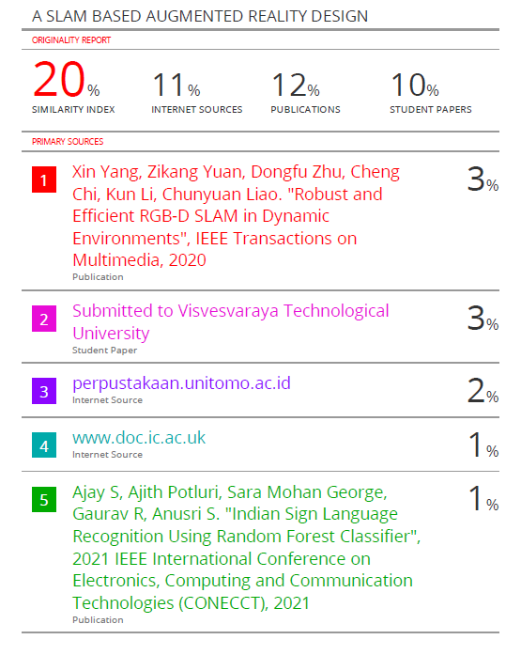









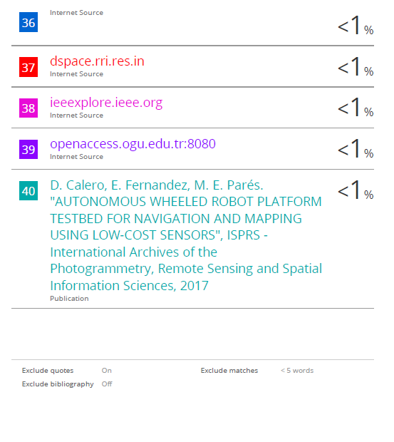

**APPENDIX A**

* **Paper Submitted in Journal:**

